Project Design Phase-II
Data Flow Diagram & User Stories

Date | 04 October 2026
Team ID | [Your Team ID]
Project Name | Script-Controlled ACL – Restrict Record Access Based on Field Value
Maximum Marks | 4 Marks

Data Flow Diagrams:
A Data Flow Diagram (DFD) is a traditional visual representation of the information flows within a system. A neat and clear DFD can depict the right amount of the system requirement graphically. It shows how data enters and leaves the system, what changes the information, and where data is stored.

Level-1 Data Flow Diagram – Script-Controlled ACL:(Simplified)
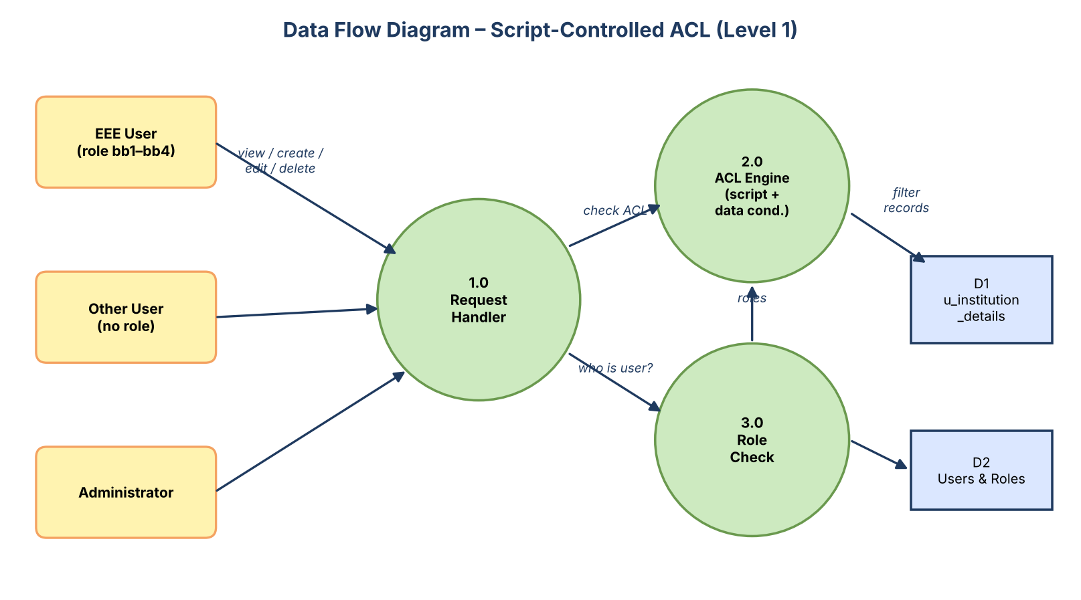

User Stories
Use the below template to list all the user stories for the product.
User Type | Functional Requirement (Epic) | User Story Number | User Story / Task | Acceptance criteria | Priority | Release
Administrator | User & Role Management | USN-1 | As an administrator, I can create a test user (EEE User) so that I can test branch-based access. | User EEEUser is saved and active | High | Sprint-1
Administrator |  | USN-2 | As an administrator, I can create the custom roles bb1, bb2, bb3 and bb4. | Four roles are visible in the Roles list | High | Sprint-1
Administrator |  | USN-3 | As an administrator, I can assign all four roles to the EEE User. | EEE User shows bb1–bb4 in the Roles related list | High | Sprint-1
Administrator | Data Model | USN-4 | As an administrator, I can create the custom table Institution Details (u_institution_details). | Table exists and is not extending another table | High | Sprint-1
Administrator |  | USN-5 | As an administrator, I can add the fields Student Roll Number, Student Name, Faculty Name, Branch, Email, Phone Number and Description. | All 7 fields appear in Table Columns | High | Sprint-1
Administrator |  | USN-6 | As an administrator, I can insert sample records for ECE, EEE and CSE branches. | 6 records are listed (2 per branch) | Medium | Sprint-1
Administrator | Read ACL | USN-7 | As an administrator, I can elevate to security_admin and create a Read ACL (record, read, advanced) on u_institution_details that requires role bb1. | ACL is saved and active | High | Sprint-2
Administrator |  | USN-8 | As an administrator, I can add the data condition Branch is EEE to the Read ACL. | Condition is visible on the ACL form | High | Sprint-2
Administrator |  | USN-9 | As an administrator, I can add an advanced script that returns true for admin / bb1 and false for everyone else. | Script saves without syntax errors | High | Sprint-2
EEE Branch User (bb1) |  | USN-10 | As a user with role bb1, I can open the Institution Details list and see only EEE-branch records. | Only INS0001007 and INS0001004 are listed | High | Sprint-2
Administrator | Create & Write ACL | USN-11 | As an administrator, I can create a Create ACL that requires role bb2. | ACL is saved and active | High | Sprint-3
EEE Branch User (bb1+bb2) |  | USN-12 | As a user with bb1 and bb2, I can see the New button and create records. | New button is visible on the list | High | Sprint-3
Administrator |  | USN-13 | As an administrator, I can create a Write ACL that requires role bb3. | ACL is saved and active | High | Sprint-3
EEE Branch User (bb1+bb2+bb3) |  | USN-14 | As a user with bb1, bb2 and bb3, I can edit the Description of EEE records inline. | Description saved as "ACL is Executed" | Medium | Sprint-3
Administrator | Delete ACL & Validation | USN-15 | As an administrator, I can create a Delete ACL that requires role bb4. | ACL is saved and active | High | Sprint-4
EEE Branch User (bb1–bb4) |  | USN-16 | As a user with all four roles, I can delete an EEE record. | Record is removed after confirmation | High | Sprint-4
User without role |  | USN-17 | As a user without the roles, I must not see any record in the list. | List shows "No records to display" | High | Sprint-4
Administrator |  | USN-18 | As an administrator, I can still see the records of all branches. | All 6 records of ECE, EEE and CSE are listed | High | Sprint-4
Administrator |  | USN-19 | As an administrator, I can document the work as a project report. | Final report is complete | Medium | Sprint-4

